Solo: On the…..
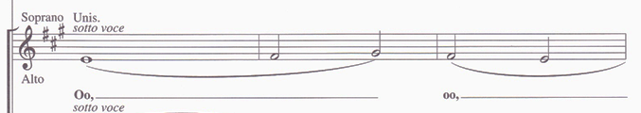
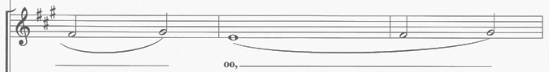
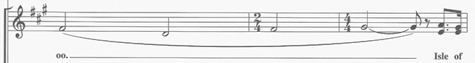

Refrain:
Isle of hope, Isle of tears,
Isle of freedom, Isle of fears,
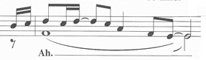
that Isle of hunger, Isle of pain___,
Isle you`ll never see again_,
but the Isle of home is always on your mind.

In her little bag, she carried all
her past and history
and her dreams for the future
in the land of Lib-er-ty
and cour-age is the pass-port
when your old world dis-ap-pears
Cause there’s no future in the past –
when you’re fifteen years

Refrain:
Isle of hope, Isle of tears,
Isle of freedom, Isle of fears,
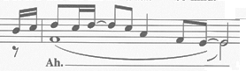
that Isle of hunger, Isle of pain___,
Isle you`ll never see again_,
but the Isle of home is always on your mind.

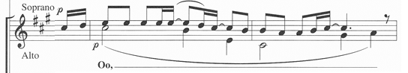
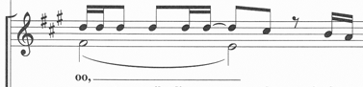
there for sanc-tu-ary

and in spring time when I came here
and I stepped on-to its piers
I thought of how it must have been,
when you’re only fifteen years___

Refrain:
Isle of hope, Isle of tears,
Isle of freedom, Isle of fears,
that Isle of hunger, Isle of pain___,
Isle you’ll never see again_,
but the Isle of home is always on your mind.

2x Refrain nach Tonartwechsel:
Isle of hope, Isle of tears,
Isle of freedom, Isle of fears,
but it’s not the Isle I left behind
that Isle of hunger, Isle of pain___,
Isle you’ll never see again_,
but the Isle of home is always on your mind.

